Lab 3

1. Install wireshark (Done)

2. Capture packets using wireshark



3. Draw an IP header.

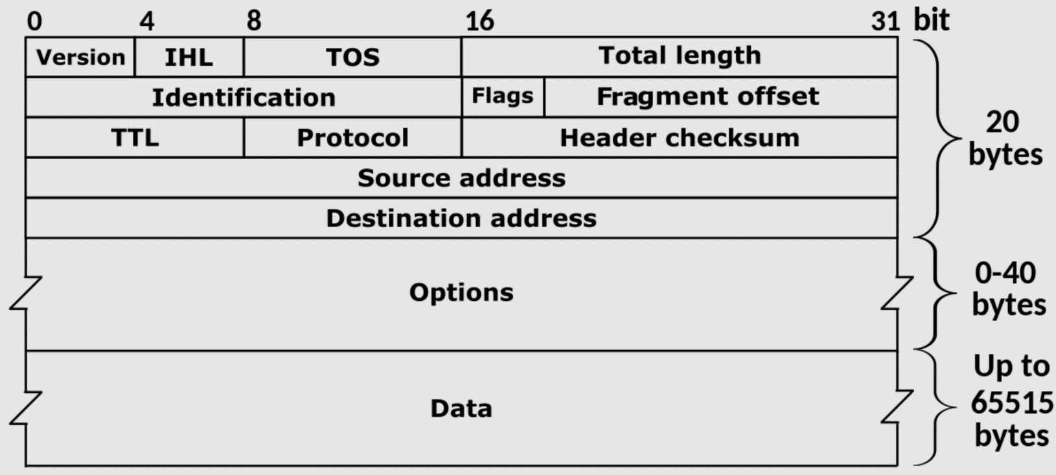

40

20 bytes (50)

Version: 4

Fragment Offset = 0

0x40

0x3c25(15397)

0x7172 unverified

TCP(6)

57

162.247.241.14

149.153.106.153

No Options

4. Explain the fields for a particular IP packet captured. Try to explain the purpose of each field.

**Version:** it specifies identity of IPv4 OR IPv6

**IHL:** This is the length of the header in 32 bit units

**TOS:** Terms of service slot assigns the priority of Ip packet, to take decisions what path should packets take through network.

**Total Length:** A 4-bit field containing the length of the Ip header that has 32bit increments. The minimum length that header can be is 20 bytes or five 32bit increments and maximum 24 bytes which is six 32bit increments.

**Identification:** it is a 16 bits slot which indicates a identifying value that has been assigned by the sender to help the assembling the fragments of an IPv4 datagram

**Flags:** This slot controls how specific packets are treated by the device

**Fragment Offset:** This slot is indicating the starting point/position of data in the fragment in relation to the start of the data in the original packet.

**TTL:** This slot is set to a number and then its decremented by every router that is being passed through. Then packet is discarded when TTL reaches 0.

**Protocol:** This slot does not identify the application, but it identifies the protocol that is above the Ip layer that is being used for application identification.

**Header checksum:** This value is calculated based on the contents of the header itself also used to check and determine if any errors have been introduced during transmission

**Source address:** Ip address of sender.

**Destination:** Ip address of the receiver.

**Options:** This slot provides instructions to the devices on the network also can provide / used to dictate the path that datagram should take.

**Data:** The data is actual content such as a value or a string of letters.

5. Here you find a network trace with fragment bit set in the IP packets. What’s the major difference from the packet you described for answering previous questions.

https://wiki.wireshark.org/SampleCaptures?action=AttachFile&do=get&target=ipv4frags.pcap

6. List three games you like and list their technical/design highlights.

Counter-Strike Global-Offensive: Fps Shooter, Tactical , Have to co-operate, use strategy competitive rank system.

Elden Ring: Open world, exploration, need to play smartly, need to learn patience, slow paste.

Need for speed Heat: Fast paste, exploration, create own design for car and cars them self.

7. List the names of applications/services you like (up to 20 names).

Discord, Steam, gimp 2, Sony Vegas 2019, Opera, Snapchat, YouTube, Twitch, Instagram, Paypal, Amazon, HomeEye, HomeSecure, Ryanair, Reddit, GitHub, Blockbench, Mcreator, Unity, Adobe After Effects,